**A2 JFSREACT ASSIGNMENT**

**SectionA2: GIT BRANCHING**

**OBJECTIVE: Commit HTML,CSS & Javascript assignments into git**

**HTML ASSIGNMENTS**

21.First take a backup of your assignments & projects. This is required because due to incorrect GIT operation you may lose your files.

22.Create an empty directory ‘Assignments’ & cd to ‘Assignments’.

23. Create a file README.txt inside ‘Assignments’ & write few lines about the contents of ‘Assignments’ folder.

24. Commit README.txt file.

22-24

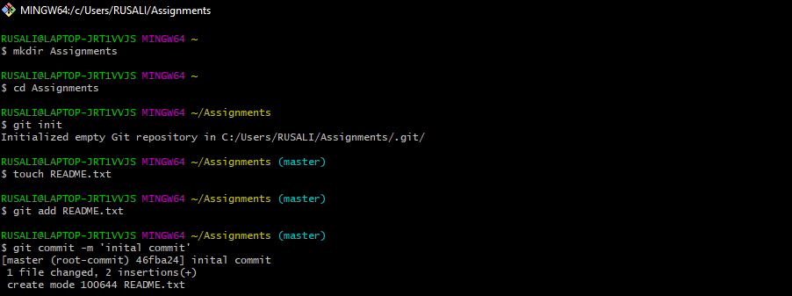

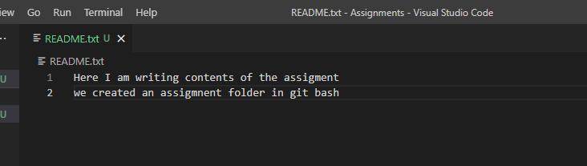

25. Now create a new branch ‘html-assignments’.

26. Switch to ‘html-assignments’ branch.

27.Copy all HTML assignments inside ‘Assignments’ folder.

Step 25-27

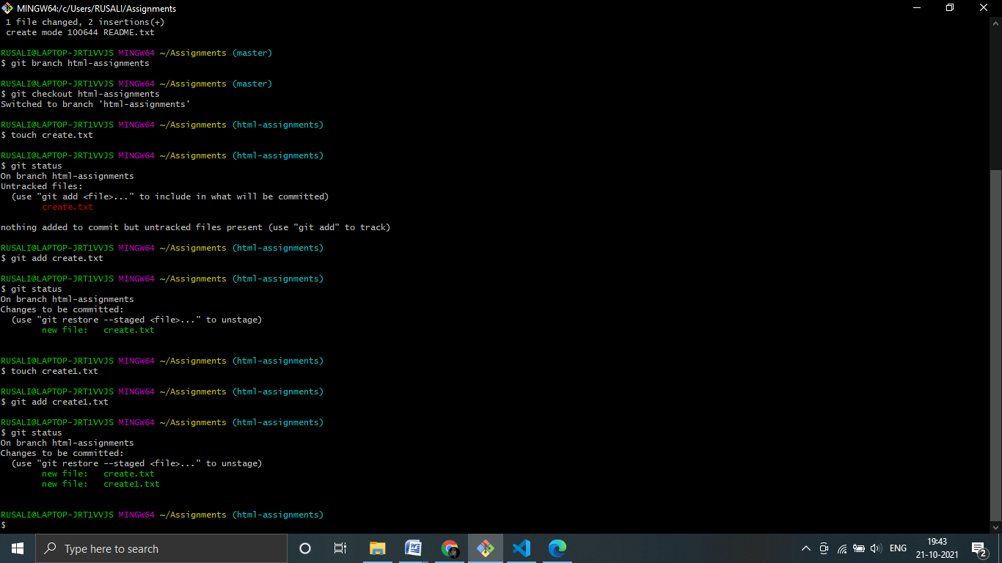

28.Commit HTML assignments into ‘html-assignments’ branch.

29.Make minor changes into few files belonging to ‘html-assignments’ branch.

30.Commit those changed files.

Steps 28-30

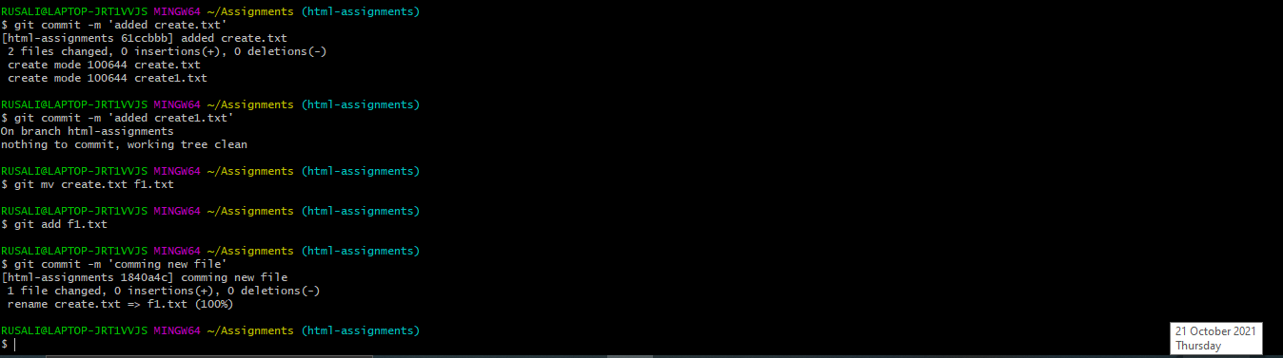

31.Switch to master branch.

32.Make minor changes into README.txt file & commit those changes into master.

Steps-> 31-32

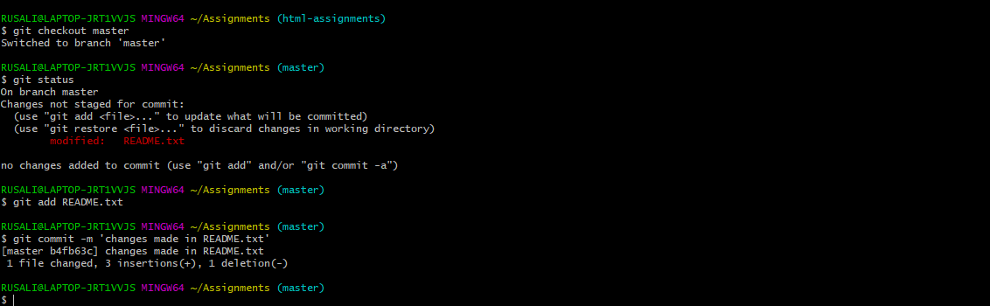

33.Again switch to ‘html-assignments’ branch.

34.Make minor changes into few files belonging to ‘html-assignments’ branch.

35.Commit those changes.

36.Switch to master.

37.Merge ‘html-assignments’ branch into master. Confirm all html assignments are shown in master.

Steps->33-37

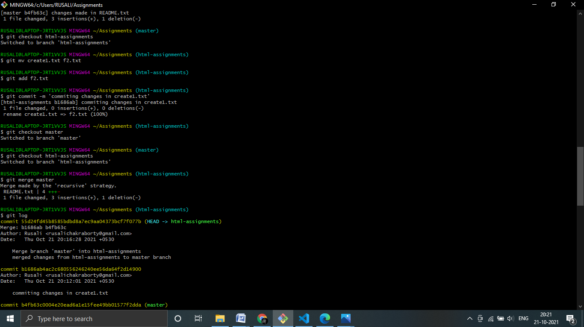

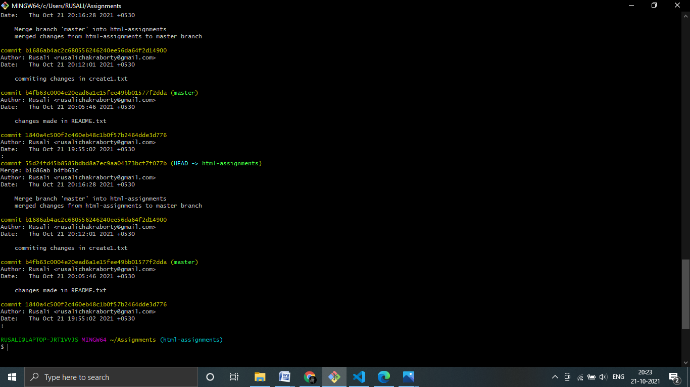

38.Finally delete the ‘html-assignments’ branch.

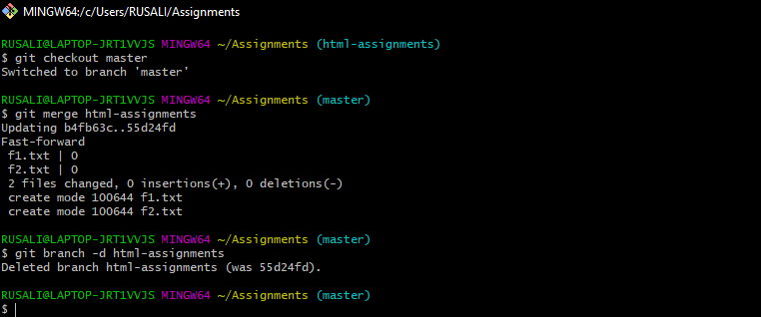

**Section 2 css assignment**

1.Create a new branch ‘css-assignments’.

2.Switch to ‘css-assignments’ branch.

3.Copy all CSS assignments inside ‘Assignments’ folder.

4.Commit CSS assignments into ‘css-assignments’ branch.

5.Make minor changes into README.txt file on line 1 belonging to ‘css-assignments’ branch.

6.Commit those changed files.

7.Switch to master branch.

Steps->1 to 7

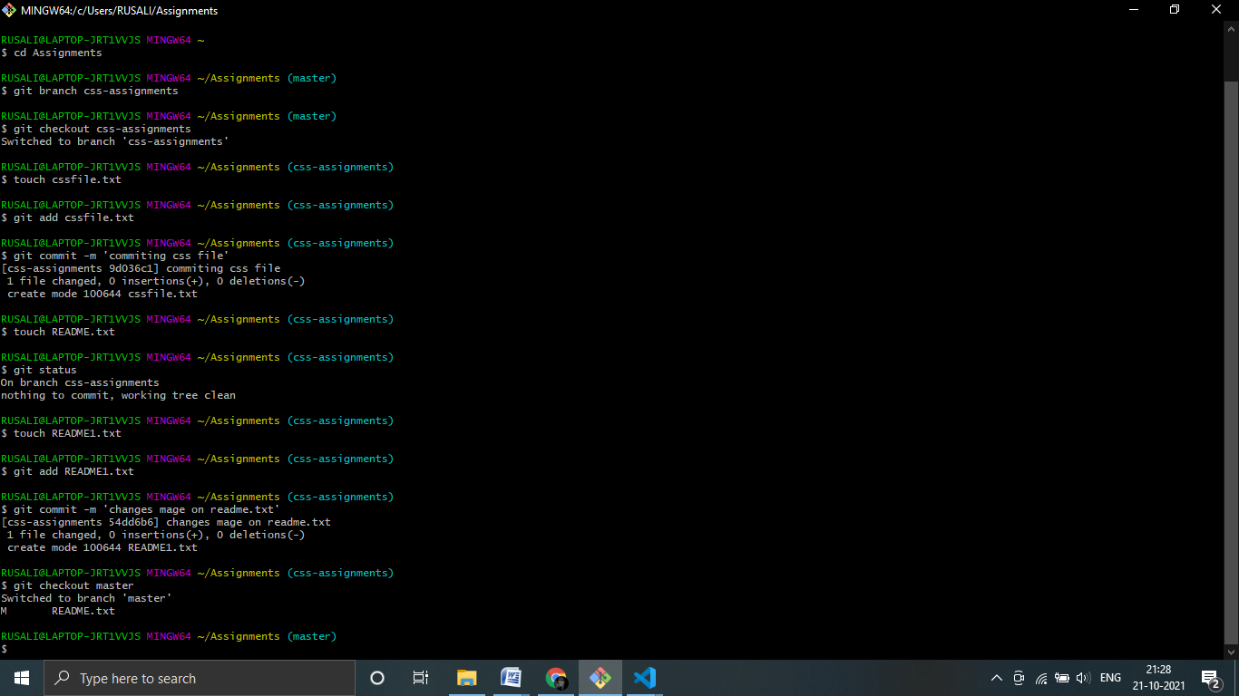

8.Make minor changes into README.txt file on line 3 & commit those changes into master.

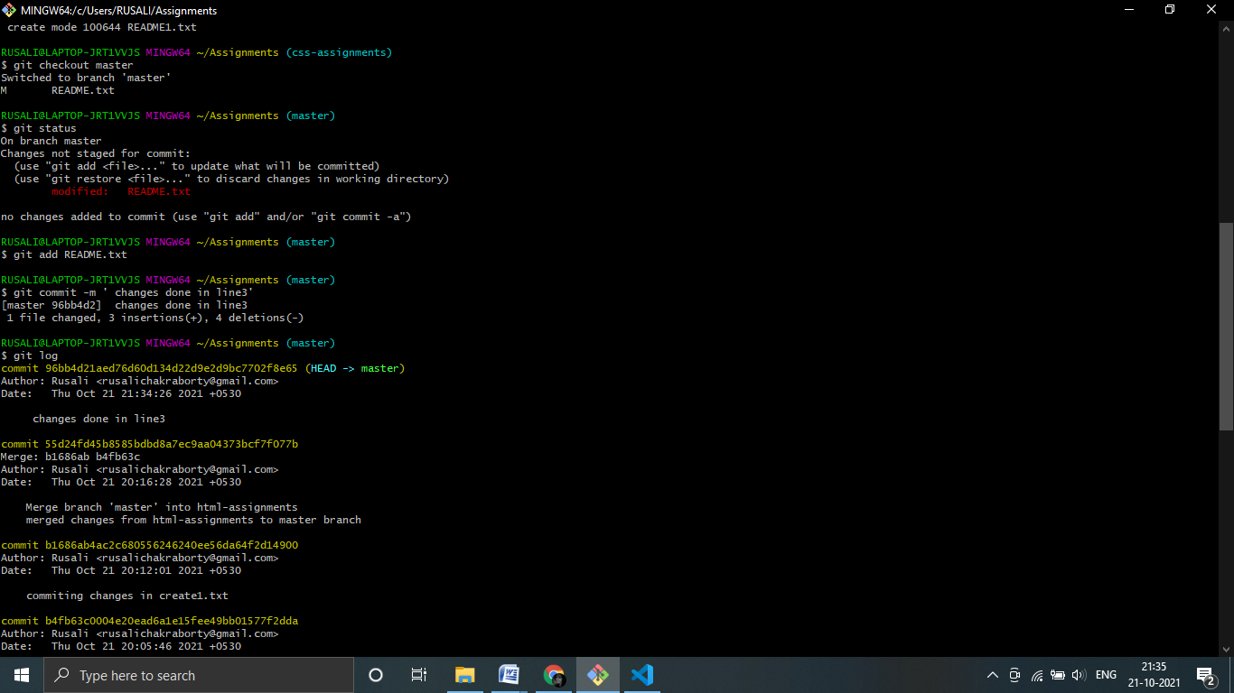

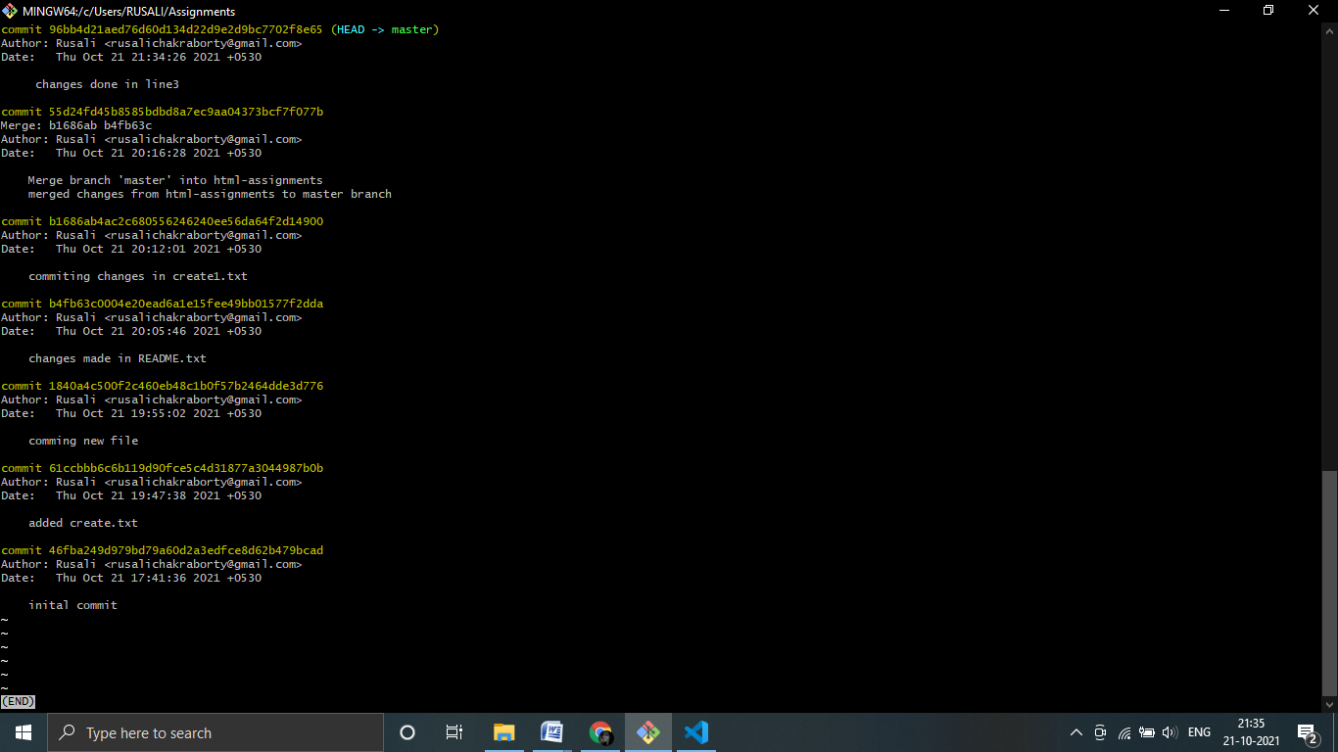

9.Again switch to ‘css-assignments’ branch.

10.Make minor changes into few files belonging to ‘css-assignments’ branch.

11.Commit those changes.

12.Switch to master.

13.Merge ‘css-assignments’ branch into master. Confirm all css assignments are shown in master.

Steps->9-13

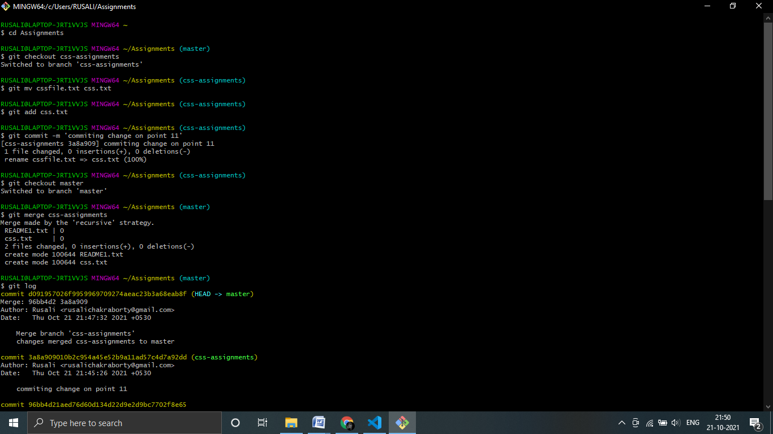

14.Finally delete the ‘css-assignments’ branch.

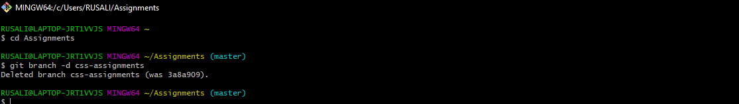

**SECTION3: JavaScript assignments**

Steps 1-7

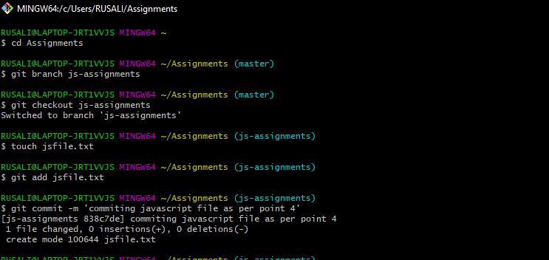

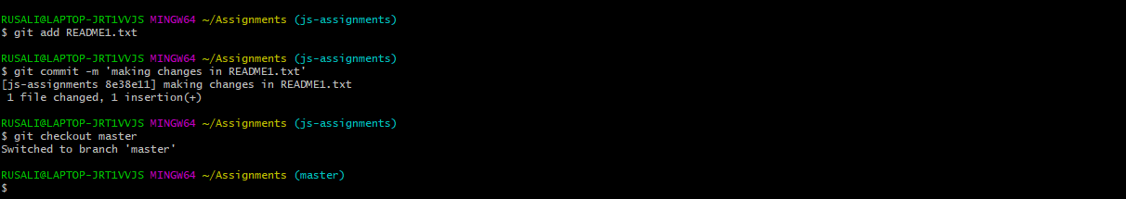

Steps 8-13

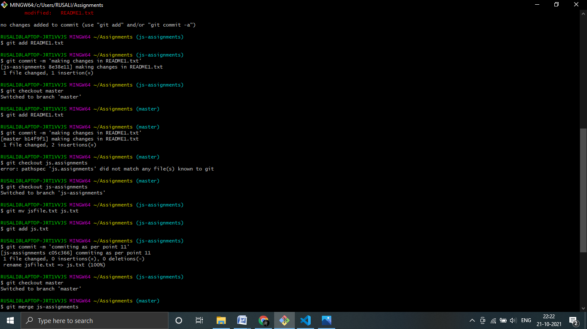

Steps->13-14

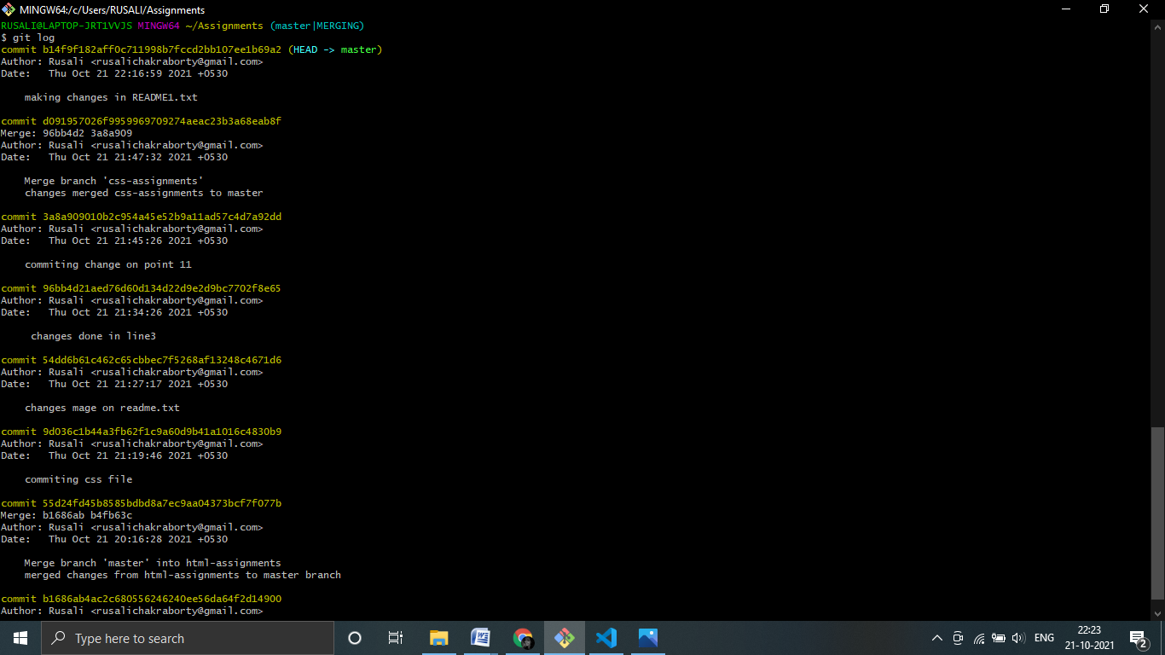

Step 14

